**Business Model Canvas**

It is a template that helps entrepreneurs to develop and think about their business idea. The Canvas business model has become very popular over the last decade. Business model have to clearly define how do you create, capture and deliver the value to the customer.

**The template is divided in nine different sections:**

**Nine Building Blocks**

1. **Value Propositions**

* What value you provide to your customers?
* Products
* Services
* Content

1. **Customer Segments**

* Who are your customers?

1. **Customer Relationship**

* How you interact with your customers?

1. **Channels**

* From where you sell and deliver your products or services.

There are two types of channels

* Sales channel
* Delivery channel

1. **Revenue Streams**

* How companies earn money? Eg online subscription commission advertising youtube fix price

1. **Cost Structure**

* What cost is involved in running the business.

1. **Key Activities**

* What you should do to run your business.

1. **Key Resources**

* What things and resources are you use to run your business?

1. **Key Partners**

* Who are your partners which are helping you to run your business?

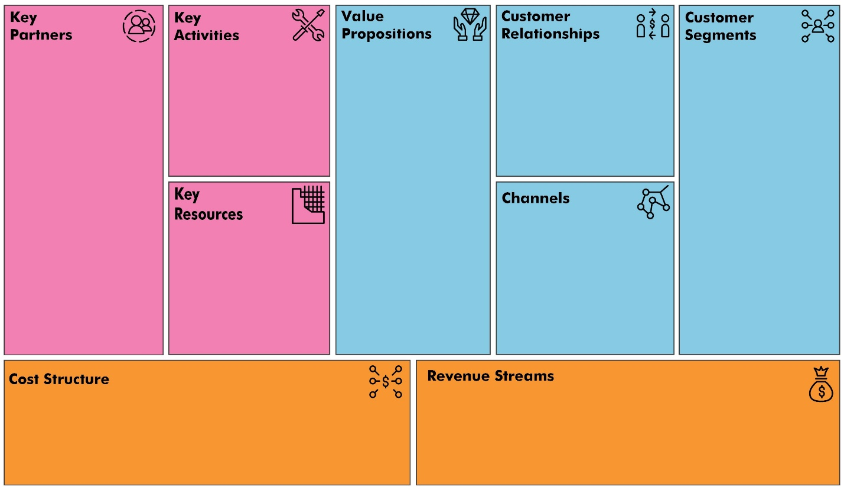

<https://designabetterbusiness.com/2017/11/02/how-to-use-the-business-model-canvas-for-innovation/>